Arsenal FC - Emirates Stadium Access Statement
2017/2018
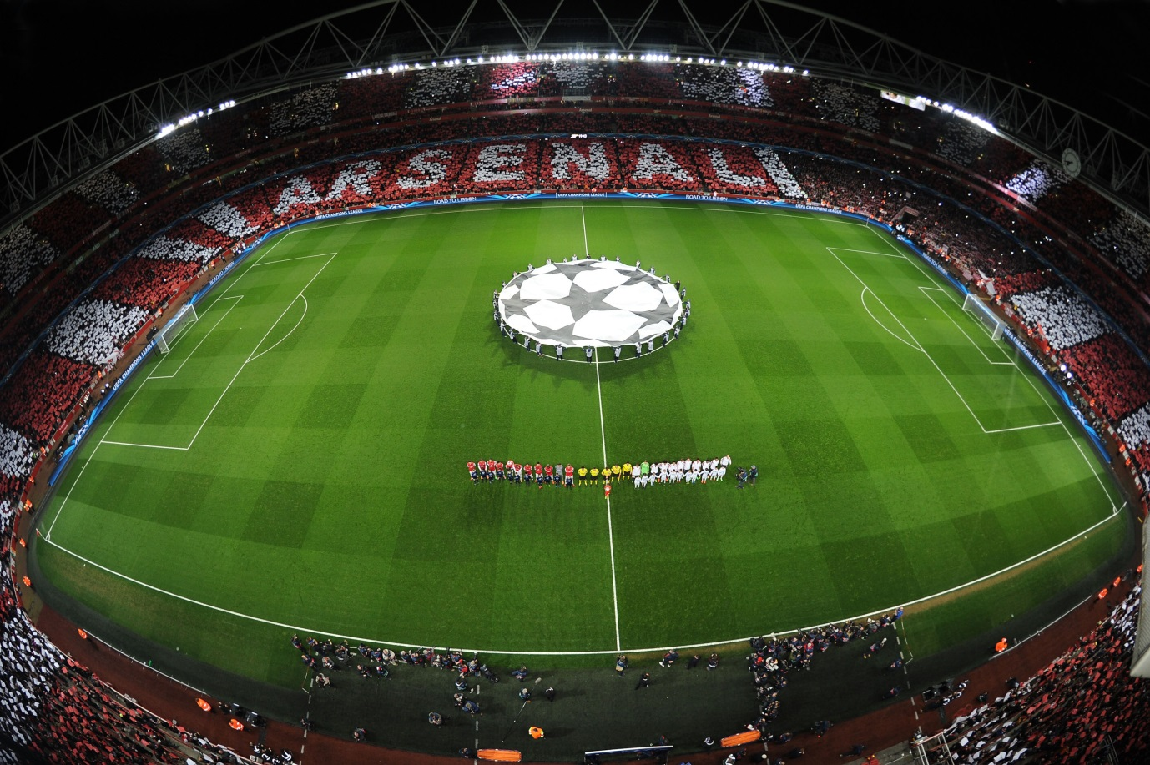

Compiled by

The Disability Liaison Team
Highbury House
75, Drayton Park
London
N5 1BU

Content
- Introduction
- How to get to Emirates Stadium – Public Transport & Parking
- Approaching the Stadium as a Pedestrian
- Non Match Day Box Office
- Match Day Box Office
- Ticket Collection Point
- Turnstiles
- Wheelchair User Platforms
- Visually Impaired & Ambulant Disabled Supporter Seating
- Wheelchair Accessible Toilets
- Changing Places Toilet
- Match Day Audio Commentary Service
- Catering Facilities
- Disabled Supporters Lounge
- Armoury Store
- All Arsenal Store
- Facilities and Services for Blind & Visually Impaired Supporters
- Contact Information

Introduction
Welcome to Emirates Stadium Access Statement which has been produced by Arsenal’s Disability Liaison Team to help you plan your journey to and from Emirates Stadium and also to provide information about access, facilities and services that we provide for disabled supporters and visitors to Emirates Stadium.
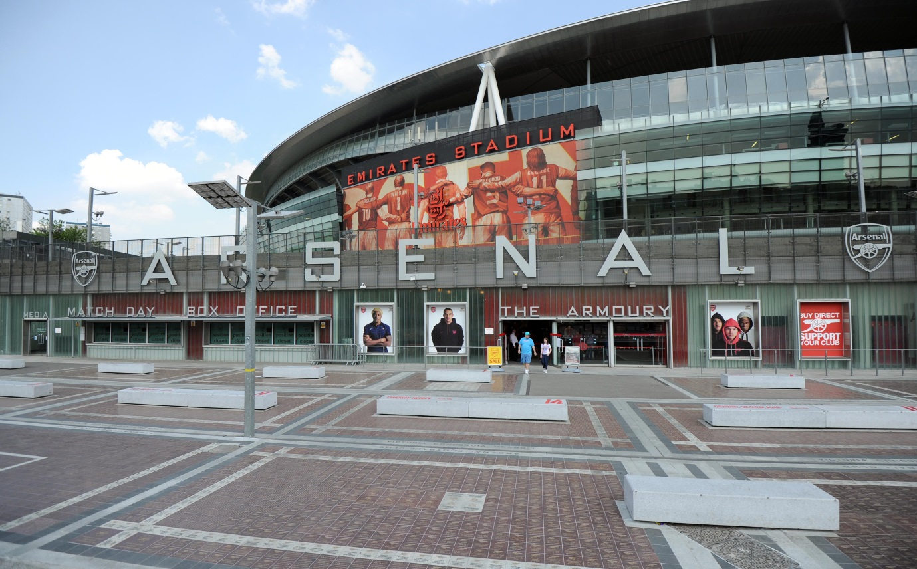
Armoury Square

How to get to Emirates Stadium - Public Transport / Parking
Underground
Unfortunately, none of the underground or mainline railway stations around Emirates Stadium are wheelchair accessible. However some ambulant disabled supporters/visitors might be able to use them.

- Arsenal (Piccadilly Line) is the nearest tube station and is around a three minute walk from the stadium.

- Holloway Road (Piccadilly Line) is around five minutes walk from the stadium. Please note that Holloway Road is exit only before and after matches.

- Drayton Park (Great Northern Rail). Closed on match days.

- Finsbury Park (Victoria, Piccadilly Lines and Great Northern Rail) is around a 10-minute walk from the stadium. - Finsbury Park will have step free access from 2018 when two new lifts will be installed serving the north and southbound platforms.

- Highbury & Islington (Victoria Line, London Overground and Great Northern Rail) is around a 10- 15 minute walk from the stadium. Note: there is lift access to from street level to both platforms used for London Overground services

- Kings Cross is the nearest main line station and is wheelchair accessible. It is around 20 minutes away by car or taxi or for ambulant disabled supporters and visitors via the Piccadilly Line (to Arsenal) or the Victoria Line (to Highbury & Islington).

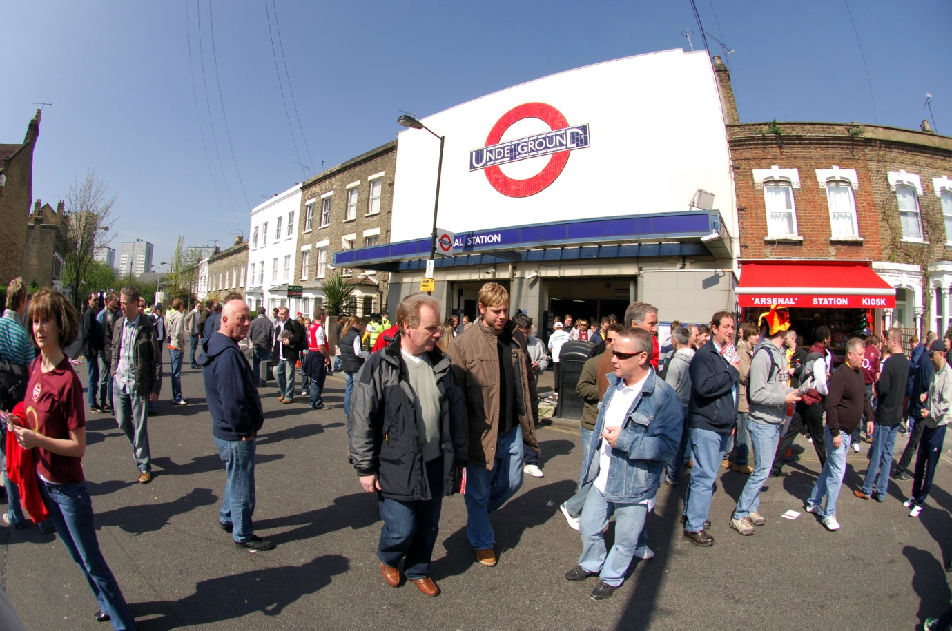
Arsenal Underground Station
Buses
All Transport for London (TFL) main bus routes are wheelchair accessible and also have clearly marked priority seats for anyone who needs them. On most buses the wheelchair ramp is positioned at the exit door and there is one wheelchair user place on each bus. Please be aware that buses can get very congested on match days.

The main bus stops close to Emirates Stadium are located on Holloway Road, Nags Head, Seven Sisters Road, Blackstock Road and Highbury Corner. A number of bus routes pass close to the stadium including the 271 which goes from Highgate Village to Liverpool Street Station, and the 43 which goes from Friern Barnet to London Bridge Station and also the 19 which goes from Finsbury Park to Battersea Bridge.

Taxis
All London Style ’Black Cabs’ are wheelchair accessible and can provide a suitable alternative to the bus or car.

Black cabs can be hailed (stopped) in the street however you may prefer to book a cab to travel to or from Emirates Stadium. There are a number of cab companies operating in London including,

Computer Cab: Tel: 020 7432 1432.
Radio Taxis Tel: 020 7272 0272
Uber Taxis also provide Wheelchair Accessible Vehicles (WAV). To book Download the Uber app and create your account (unless you already have one) then choose the ‘uberWAV’ option on the slider at the bottom of the screen and follow the instructions.
If you would prefer to book a mini cab then there are a number of companies in Islington including;

Yellow Cars Tel: 020 7609 4444
Islington Taxis Tel: 02036 332 363
Kwik Cars Tel: 020 7700 1400

Suggested drop off/pick up points outside Emirates Stadium are either outside The Armoury Store (on Hornsey Road) which is within 50m of the Media Entrance, which disabled supporters can use on request, giving level access into the stadium. Or on Drayton Park by the Danny Fiszman Bridge, which gives step-free access to the south-east side of the Stadium. Please note that due to the match day road closure area you may have to wait for up to an hour after a game for a taxi to come and pick you up from close to the stadium.

Full information on bus taxi and tube travel for disabled people can be found at www. tfl.gov.uk/transport-accessibility

Parking
Match Day – on street parking
Supporters are strongly advised not to drive to Emirates Stadium, as the ground is situated in a mainly residential area with extensive Match/Event Day parking restrictions.
Blue Badge holders can park in the surrounding roads in vacant residents parking bays. However, you should check to ensure the bay is not suspended due to event day parking restrictions around the stadium. Please ensure that your Blue Badge and clock are clearly displayed.
There are also a number dedicated Blue Badge bays in the vicinity of the stadium however, please be aware that some of the bays in the area are specifically for the use of a designated Blue Badge holder. Please check the Blue Badge parking signage carefully before parking.

Match Day – Stadium parking spaces for home supporters with Blue Badges can be booked through the Disability Liaison Team. Over 90 Blue Badge bays are available (around half of which are allocated to season ticket holders) and, any disabled supporter (you do not necessarily need to be a disabled member), in possession of a ticket and a valid ‘Blue Badge’ can apply to park in the stadium car park. Full details on how to book can be found on the Disabled Supporters Information page on Arsenal.com or by emailing bluebadgeparking@arsenal.co.uk Parking for Blue Badge holders is complimentary.
Away supporters wishing to book Blue Badge parking at Emirates Stadium should contact their clubs Disability Liaison Officer or Box Office.
Please note that you will not be able to exit the car park for an hour (or possibly longer) after the end of the game.
Non Match Day Parking for Blue Badge Holders
There are non-match day parking restrictions in place, but Blue Badge holders can park in all the surrounding roads either in a vacant resident’s bay, or a dedicated Blue Badge Bay – please note that some Blue Badge Bays are spacifically for the use of a designated Blue Badge holder, check the signs carefully before parking.

Approaching Emirates Stadium as a Pedestrian
Emirates Stadium is built on a podium above the surrounding street level.
- From the South (Holloway Road and Hornsey Road) access from street level is via either a flight of steps or a ramp.
There is a ramp up to podium level on Hornsey road, at the south west corner of the stadium.
There is also a ramp up to podium level on Benwell Road, next to the Arsenal Community Hub.
There are also two flights of 40 steps, with handrails, up to the podium which are located either side of The Armoury Store and the Match Day Box Office
- From the East on Drayton Park, opposite the Drayton Arms pub, pedestrians can access the stadium by the Danny Fiszmann Bridge which is step free.
- From the North East, again on Drayton Park, near to the Arsenal underground station pedestrian access is by the Ken Friar Bridge. This bridge has stepped access (50+ steps) up from Drayton Park and then ramped access on the stadium side.

- Non Match Day Box Office
The non-match day box office is located on Drayton Park next to the steps up to the Ken Friar Bridge.
There is level access to the non-Match Day Box Office and two of the seven windows have lower counters for wheelchair users.
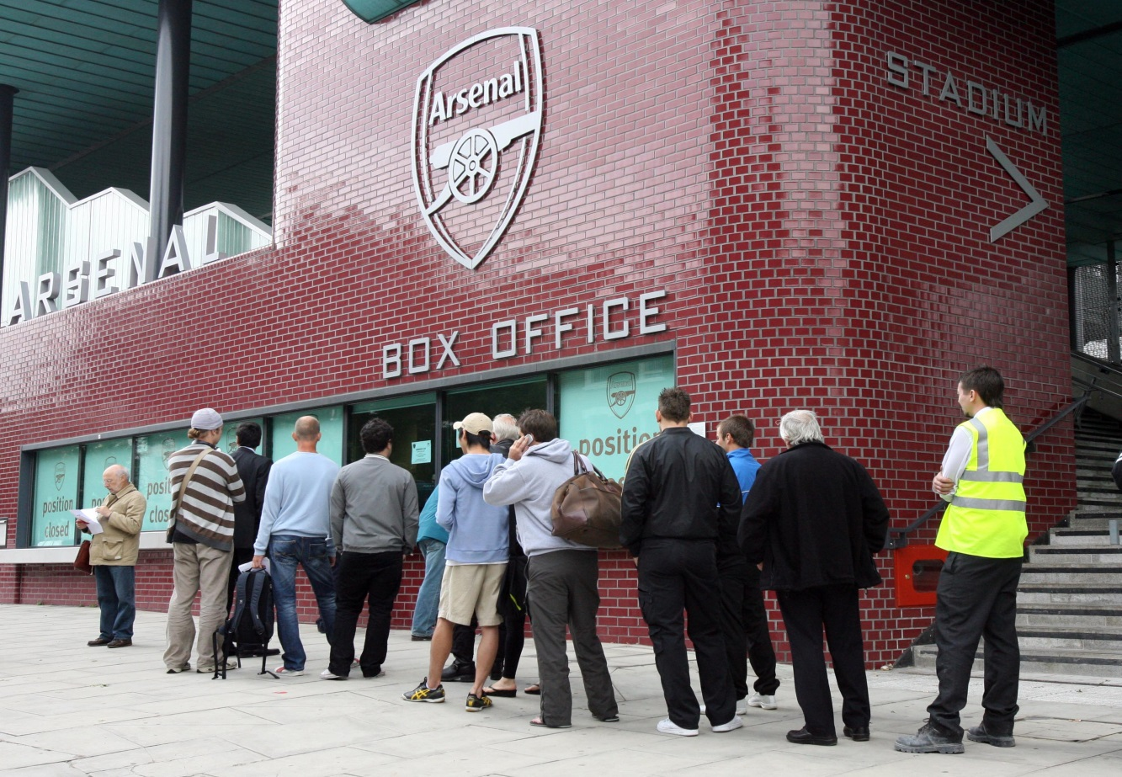Non-match day Box Office

The Match Day Box Office
The Match Day Box Office is located on Hornsey Road (at the southern end of the stadium) next to The Armoury Store.
There is level access to the Match Day Box Office. The box office is fitted with a hearing loop system for hearing impaired supporters.
There are 10 windows and there is a queuing system which is managed by stewards during busy times. However, disabled supporters who are unable to stand can avoid the queue by asking to use the window on the far left of the Box Office (just inside the door to the Media Entrance) which also has a lower counter for wheelchair users.
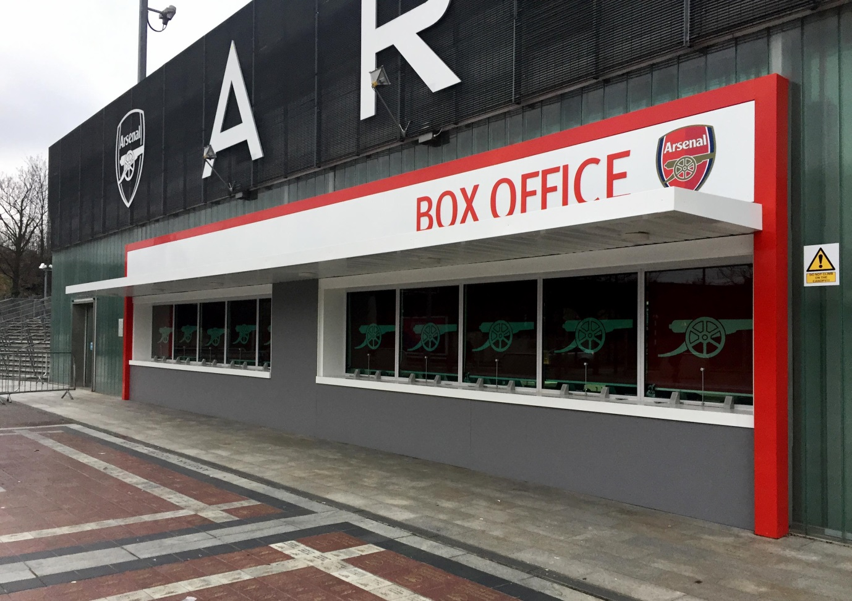
Match Day Box Office
Ticket Collection Point
The ticket collection point is located on podium level opposite turnstile block S. There is level access to the ticket collection point. Please note that the Ticket Collection Point is for pre-arranged ticket and duplicate ticket collection only.
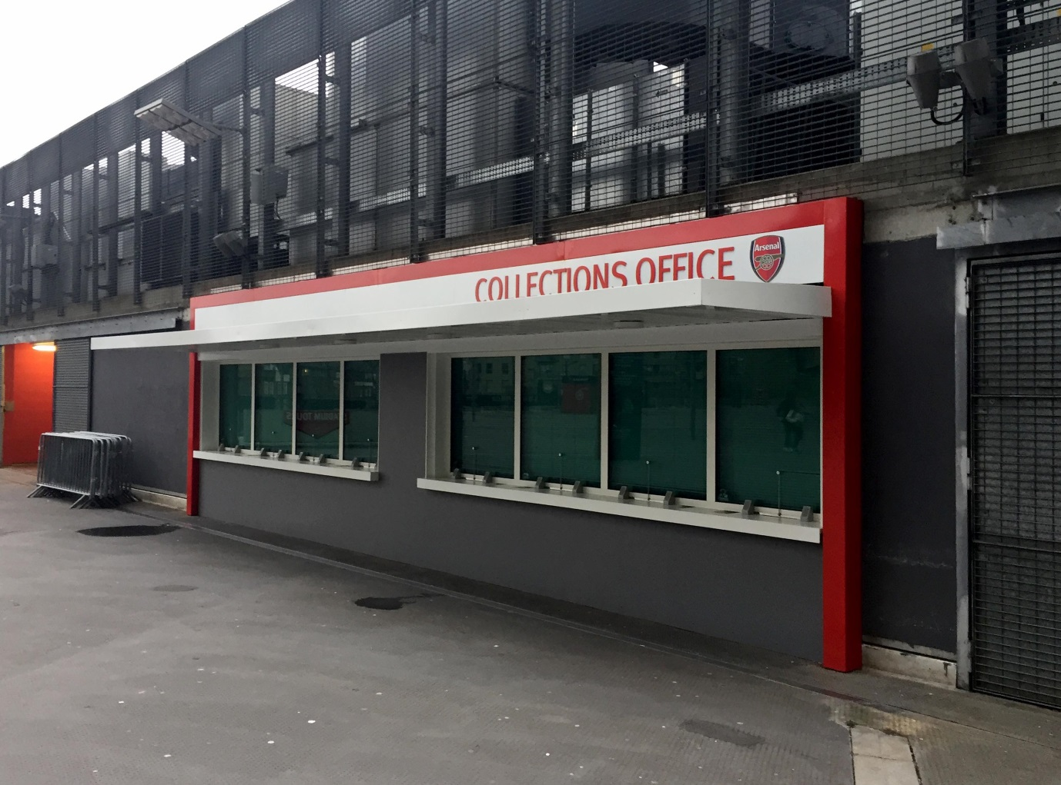
Ticket collections office
Turnstiles
Access into the stadium from podium level is via turnstiles. There is level access to the turnstile blocks. There are 16 turnstile blocks in total and turnstile blocks A, D, E, H, J, K, M, N & S all have wheelchair access gates which can be used by both wheelchair users and ambulant disabled supporters.
The outer gates (photo A below) are operated by disabled supporters inserting their membership card into a card reader. Stewards are on hand to assist if required. Once inside, the inner gate (photo B below) will then be opened to allow access into the lower tier concourse.
Please note that the club advises all supporters to arrive at Emirates Stadium in good time due to security checks on entry
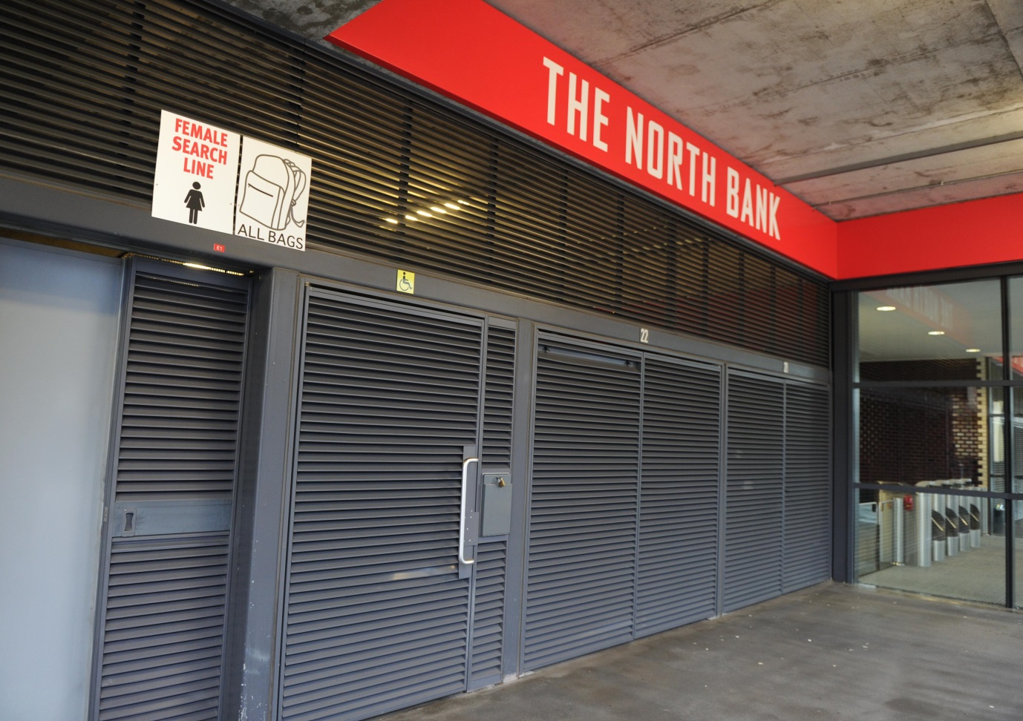
Photo A
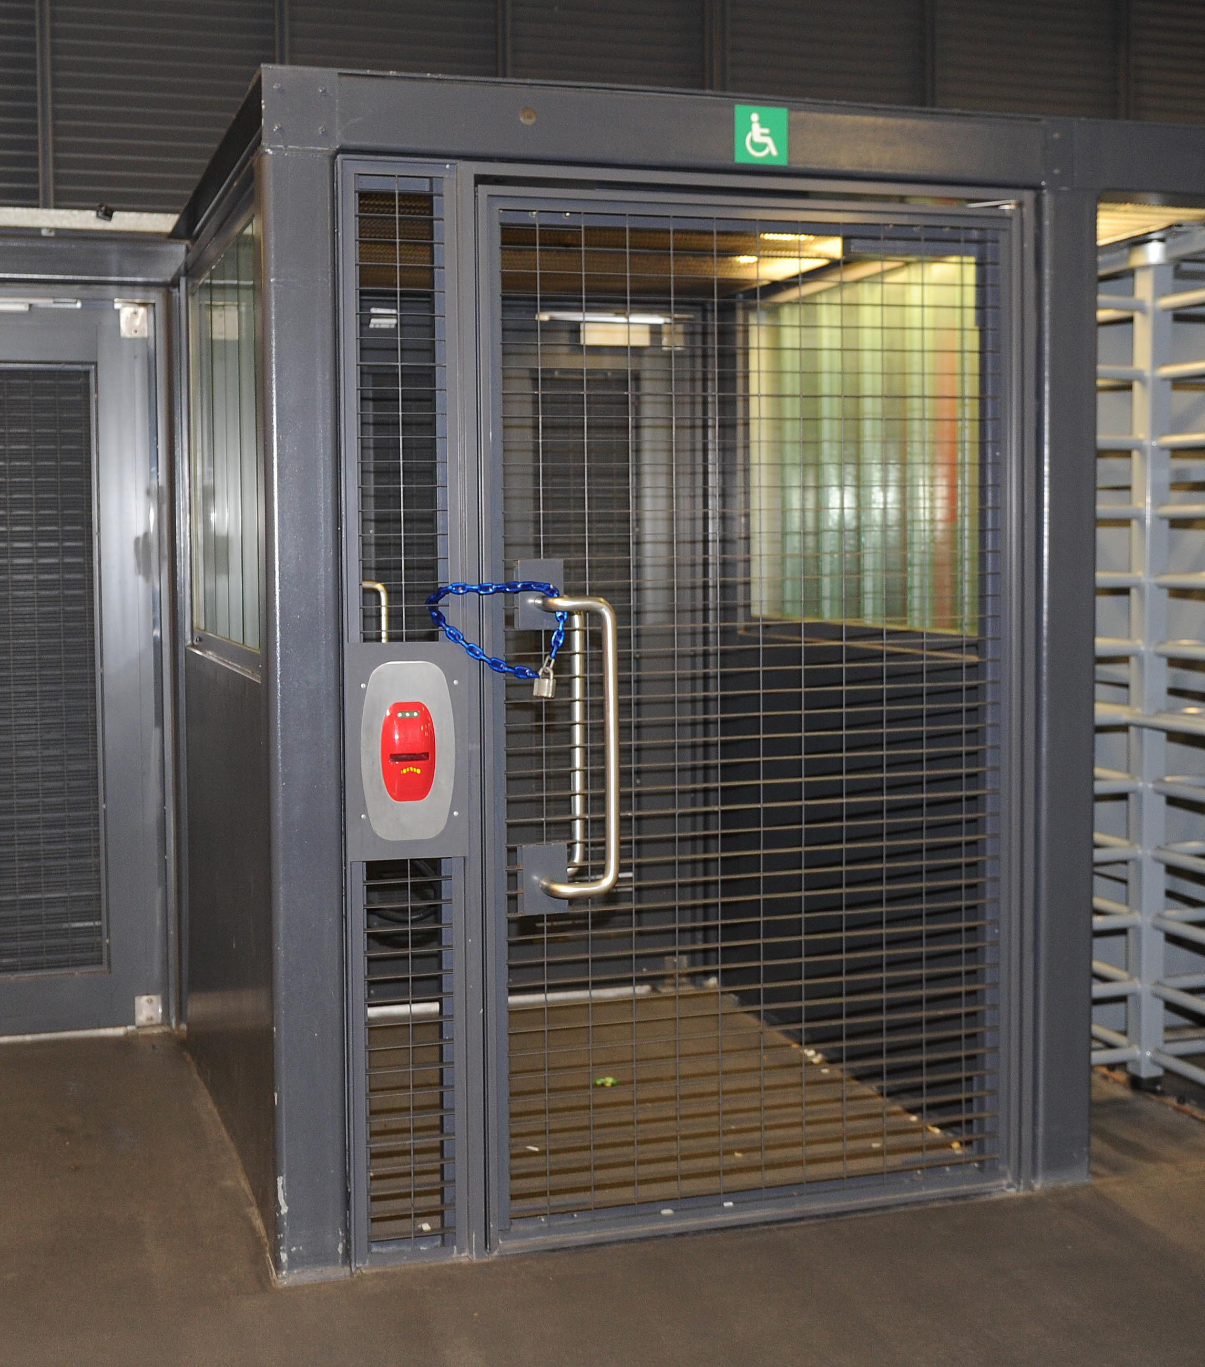
Photo B
Lifts
There are nine lifts inside the stadium which disabled supporters can use to go from the car park level to the Lower Tier, Club Level, Box Level and the Upper Tier.
The lifts are located at the following cores; A/B, C/D, E/F (which has two lifts), G/H, J/K, L/M, N/P and R/S. All lifts are stewarded on match days and disabled supporters and people with mobility problems have priority at all the lifts and, from half an hour before kick -off E/F and N/P lifts are designated for disabled supporters only.
The lifts have visual floor indicators an audible announcer, hearing loops and tactile markings on the control buttons.

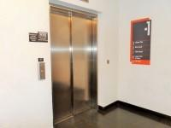
Lift lobby area on car park level
Wheelchair Platforms
Lower Tier.
There are 12 platforms for wheelchair users on the Lower tier, 11 for home supporters and 1 for away supporters. The platforms are all located at the rear of the Lower Tier.
The platforms are all accessed via ramps (stewards are on hand to assist if required). Wheelchair users sit at the front of the platforms and their enablers sit behind them at the back of the platforms.
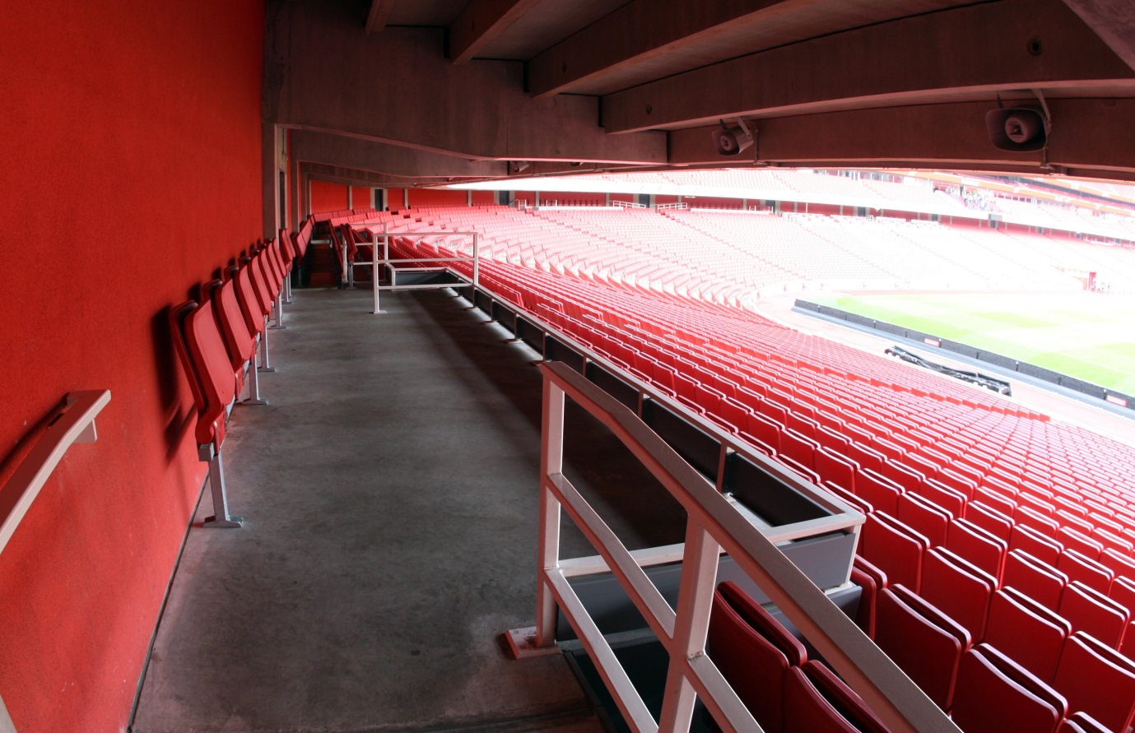
Lower Tier Wheelchair User Platform

Upper Tier
There are 8 platforms for wheelchair users on the upper tier. All of which are for home supporters except for some FA Cup games where the away club takes the increased allocation.
The platforms are all accessed by ramps (stewards are on hand to assist if required) and enablers seating is located next to the wheelchair users.

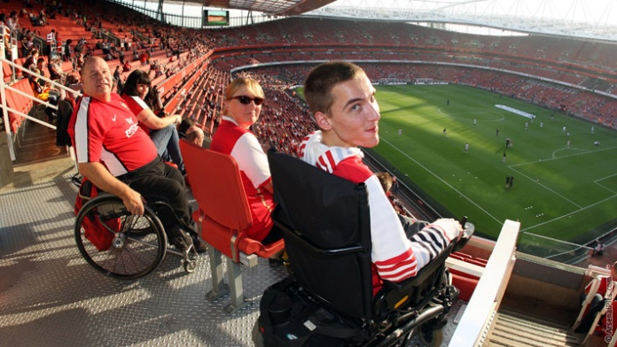
View from Upper Tier Wheelchair Platform

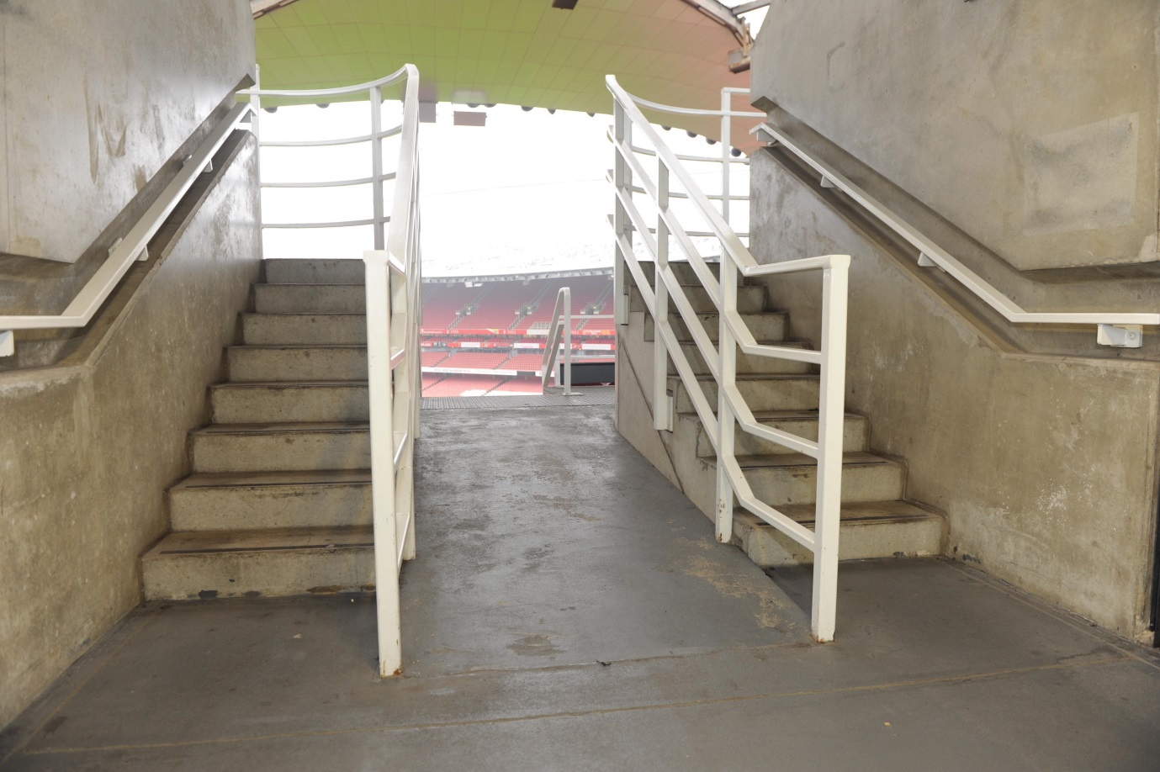
Ramped Entrance to Upper Tier Wheelchair Platform

Club Level
There are two wheelchair platforms on Club Level which are for home supporters only.
There is level access onto the platforms via double doors from inside the Club Level bar and restaurant area. The doors are manually operated and quite heavy (stewards are on hand to assist if required). The enabler’s seating is located next to the wheelchair users.
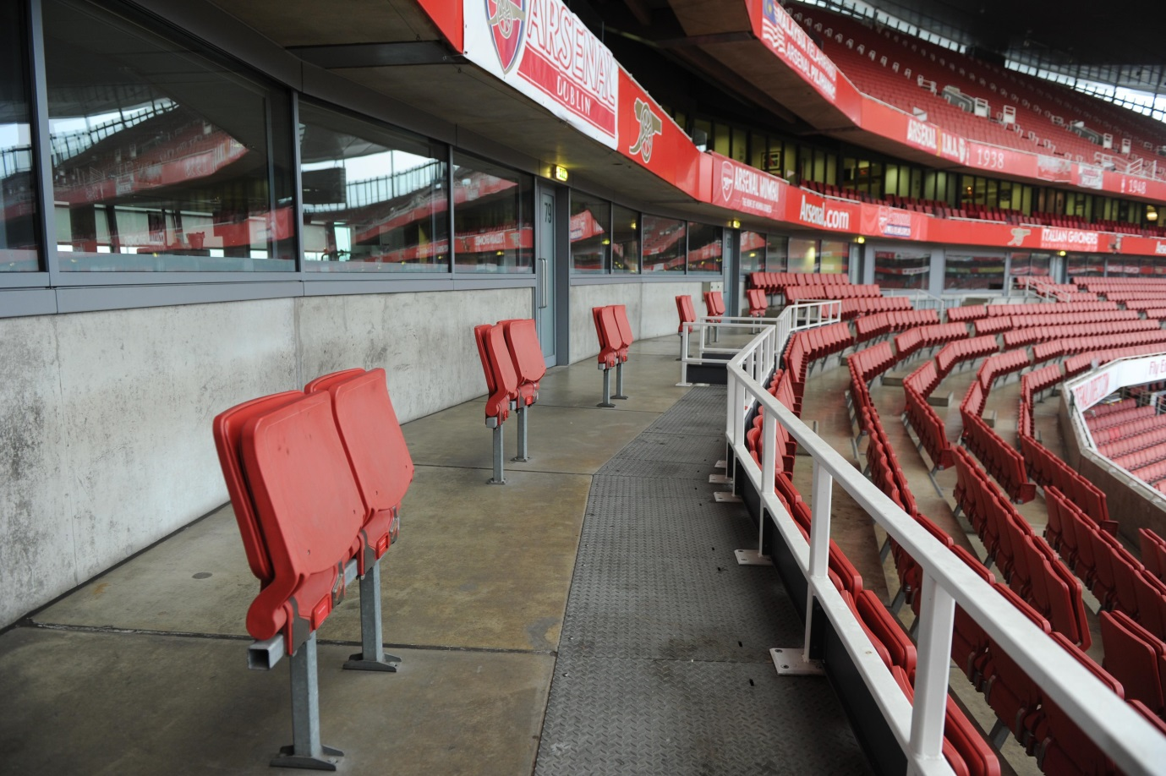 Club Level Wheelchair Platform

Visually Impaired and Ambulant Disabled Supporter Seating
Seating for Visually Impaired and Ambulant Disabled supporters is generally located in the rows immediately in front of the Lower Tier and Upper Tier wheelchair platforms as this means that supporters have level access from the concourse and then only one or two steps down to their seats.
Also, on request, and subject to availability, visually impaired and ambulant disabled supporters can sometimes be allocated adjacent enabler seats on the Lower Tier wheelchair platforms.

Wheelchair Accessible Toilets
There are 37 wheelchair accessible toilets located inside the stadium. All are fitted with RADAR locks to prevent abuse by non-disabled supporters. All supervising stewards hold RADAR keys in case a disabled supporter/visitor doesn’t have one with them.
All the wheelchair accessible toilets are unisex and the toilet doors all open outwards. The dimensions of the accessible toilet are 180cm x 235cm (5ft 11in x 7ft 9in). Either a left or right transfer space is available in every wheelchair accessible toilet along with colour contrasted grab rails.
The lateral transfer space is 110cm (3ft 7in). The wash hand basins all have lever type mixer taps. The wheelchair accessible toilets are also fitted with appropriate height mirrors, hand dryers and coat hooks and pull cord emergency alarms.
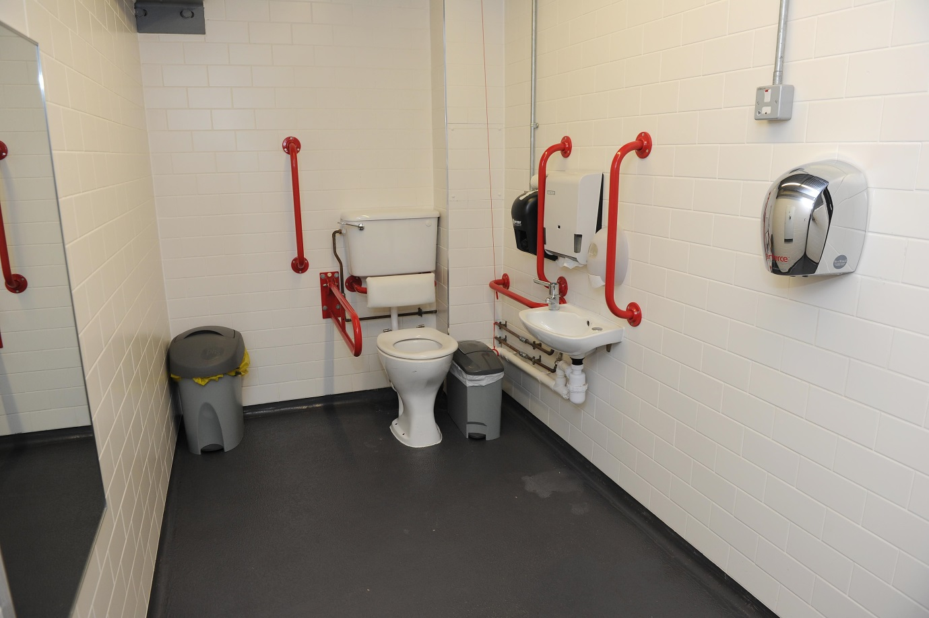
Wheelchair Accessible Toilet
Standard Toilets
There are standard male & female toilets available next to all the entrances to seating areas on the lower and upper tiers and also on Club Level next to the restaurant and bar areas. Every standard toilet block contains one cubicle suitable for ambulant disabled supporters.
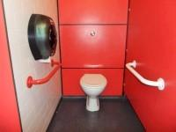
Cubicle for ambulant disabled supporters
Changing Places Toilet Facility
The Changing Places Toilet (CPT) is in Block 48 on Club Level. It is available to any disabled supporter in the stadium on a match day or a non-match day and it is fitted with a RADAR lock.
On a match day disabled supporters not on Club Level wanting to use the CPT facility should contact the Disability Liaison Team (DLT) via any steward and a member of the DLT will come and escort you from your seat/wheelchair place to the CPT facility and back again.
The dimensions of the CPT facility are 205cm x 410cm (6ft 9in x 13ft 5in). The facility includes a height adjustable changing bench (length 179cm- 5ft 10in), with shower attachment and a powered overhead hoist which covers all areas of the facility.
The toilet in the CPT facility is peninsular. The transfer space on the left as you face the toilet is 60cm (1ft 11.5in) and on the right is 96cm (3ft 2in). Colour contrasted wall mounted and drop down grab rails are fitted around the toilet.
The facility also includes a sink, a privacy screen, non-slip flooring and a pull cord emergency alarm.
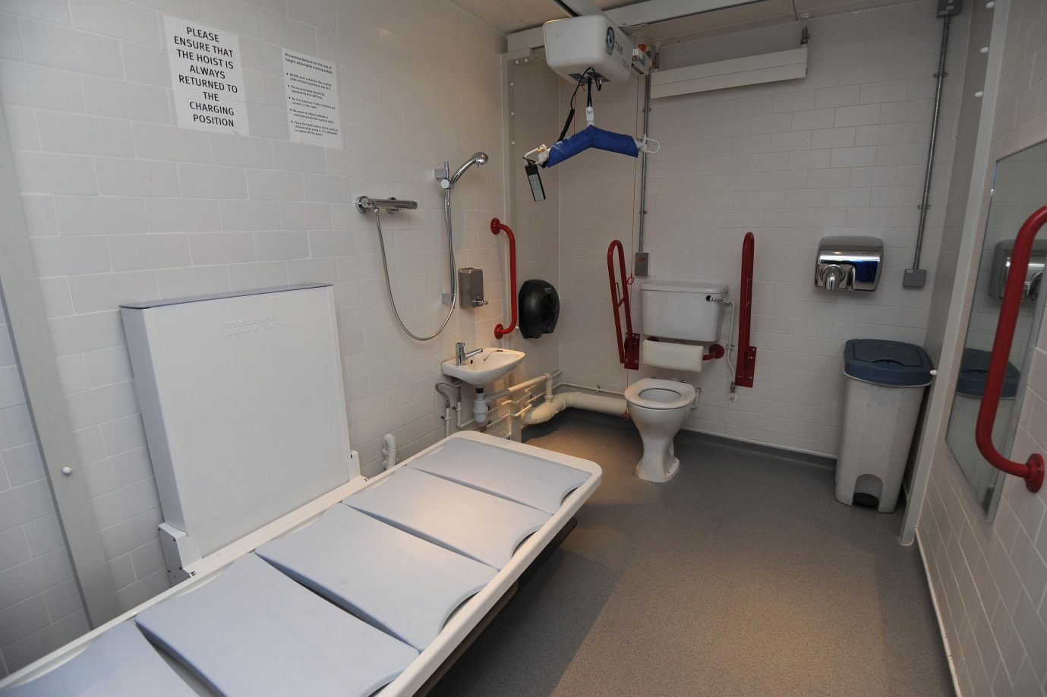
Changing Places Toilet Facility

Catering Facilities
Lower Tier & Upper Tier:
There are numerous catering areas on the Lower and Upper Tiers. All of which have varied menus of hot and cold fast food such as fish and chips and burgers as well as hot and cold drinks. All the larger catering areas have low level counters for wheelchair users.
Club Level:
There are both restaurant and bar areas on Club Level. All bar counters have a low level position for wheelchair users and both the Emirates Lounge and the Champions Bar areas, which are adjacent to the two Club Level wheelchair platforms, have drinks tables which are designated for disabled supporters during the busy half-time period.
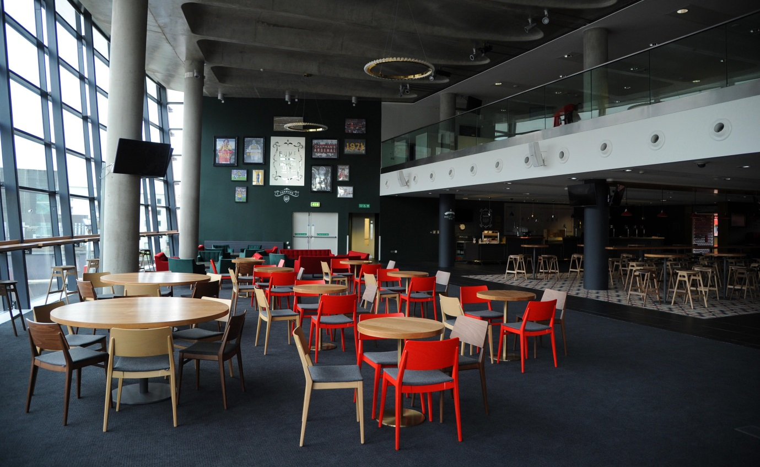
Royal Oak - Club Level Restaurant Area

Disabled Supporters Lounge
The Disabled Supporters Lounge is open for disabled supporters (and their enablers) before every home game at Emirates Stadium, (excluding the Emirates Cup weekend and International Friendlies).

- For weekend games, the Lounge opens from two hours before kick-off and closes 25 minutes before the game starts.

- For mid-week games the Lounge opens from 6.00pm and closes 25 minutes before the game starts.

The Lounge is equipped with two large screen TVs and there is also free tea and coffee available (although we do ask disabled supporters to consider making a small donation to The Arsenal Foundation for the refreshments). A wheelchair accessible toilet facility is also available.

The Disabled Supporters Lounge is located just inside the Museum Entrance which is outside the stadium in the Northern Triangle Building on podium level opposite turnstile Block E. Once you are inside The Arsenal Museum entrance, the Disabled Supporters Lounge is on your right.

For disabled supporters in the car park, you can reach the Lounge through the door marked Disabled Supporters Lounge located at the rear of Orange Car Park 4 then via a lift up to the museum entrance and the Lounge will then be on your left.
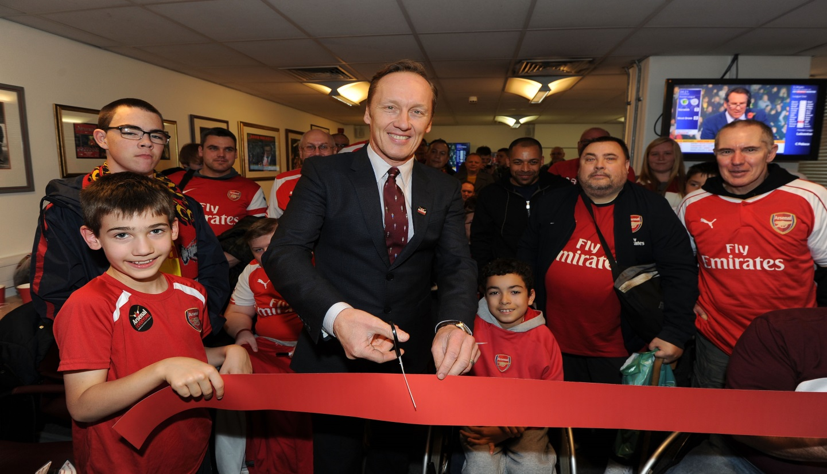
Arsenal Legend Lee Dixon opening the refurbished Disabled Supporters Lounge in October 2015
Armoury Store
The Armoury Store is located at the southern end of the stadium on Hornsey Road next to the Match Day Box Office.
There is level access into the store via double glass doors. The doors are quite heavy; however staff are on hand to assist if required. Exit from the store is through another set of double glass doors. Again, staff will be on hand to assist if needed.
Staff will also be happy to assist disabled supporters/visitors with their shopping if required. However, the store can get very busy on match days and disabled supporters/visitors requesting assistance might have to wait a few minutes for a member of staff to become available.
Except on match days disabled supporters/visitors can also book tours of Emirates Stadium in The Armoury Store.

Emirates Stadium Tours
Both the Legends and self- guided audio tours are fully accessible for wheelchair users and ambulant disabled supporters.
However, British Sign Language (BSL) users do need to contact the club before booking their tour so that we can arrange for a BSL interpreter to be present. Please email tours@arsenal.co.uk

Museum
The Arsenal Museum is located in the Northern Triangle Building opposite turnstile Block E. There is level access into the Museum entrance from where you can use a lift or stairs to go down to the Museum. A wheelchair accessible toilet is available at the Museum entrance.

All Arsenal Store
The All Arsenal Store is located on Drayton Park next to the non match day box office. There is level access into the store through double glass doors. Exit is through another set of double glass doors. Staff are on hand to assist if required.
Part of the store is at a lower level which can be reached via a short flight of stairs or a platform lift. The platform lift is kept locked for safety reasons; please ask a member of staff if you want to use it.

Services and Facilities for Blind & Visually Impaired Supporters
The Disability Liaison Team provides an Audio Description Commentary Service at every home game at Emirates Stadium for Blind and Visually Impaired supporters (including away supporters).
Season ticket holders keep their receivers and headsets on a permanent basis. Match ticket holders are handed the equipment before the game and it is then collected afterwards. This service is complimentary.
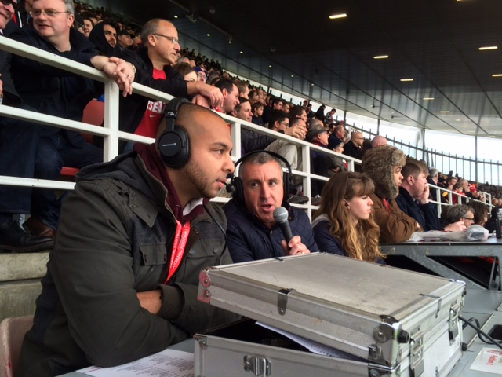Arsenal Legend Nigel Winterburn with the audio description commentary team.
The club also provides Blind and Visually Impaired Supporters with an audio version of all home match day programmes in the form of a podcast which supporters can be downloaded from the Disabled Supporters Information page on Arsenal.com a few days after each home game. This service is also complimentary.

Guide Dog Toilet Facility
Emirates Stadium was the first Premier League ground to install a Guide Dog Toilet facility. The facility is located outside the stadium on podium level opposite turnstile Block F. It is accessed via a get which is fitted with a RADAR lock.

Tactile Guidance Pathway
There are Tactile Guidance Pathways that our blind and visually impaired supporters can use to navigate their way around the podium area outside the stadium.
The pathways begin on the Ken Friar and Danny Fiszman bridges at the north and east side of Emirates Stadium and guide our visually impaired visitors around the site to Hornsey Road at the southern at the stadium.

Contact Information
The Disability Liaison Team can be contacted by:
Post – Highbury House
75, Drayton Park
London N5 1BU

Phone 020 7619 5050 (9.30am to 5.00pm Monday to Friday excluding Bank Holidays)
Fax 0207 704 4041
Email:
General Enquiries disability@arsenal.co.uk
Tickets disabilitytickets@arsenal.co.uk
Parking bluebadgeparking@arsenal.co.uk
Follow the Arsenal Disability Liaison team on Twitter by clicking here @AFC_Disability

